Difficulty Level Identification of Indonesian and Mathematics Multiple Choice Questions using Machine Learning Approach
Shabrina Retno Ningsih*, Ade Romadhony
School of Computing, Telkom University, Bandung, Indonesia
Email: ^{1,*}shabrinaretno@student.telkomuniversity.ac.id, ²aderomadhony@telkomuniversity.ac.id
Correspondence Author Email: shabrinaretno@student.telkomuniversity.ac.id
Submitted: 14/06/2023; Accepted: 29/06/2023; Published: 29/06/2023
Abstract−Examination question design is an important factor that could improve education, which could help teachers to analyze student understandings. Designing question should consider difficulty level, which commonly classified into three types: easy, medium, difficult. Predicting the difficulty level of questions is very important to help teachers form questions and know the level of student ability. In this study, we tackle question difficulty level identification as a classification problem. We use a dataset of Indonesian and mathematic question from elementary and junior or school exercise questions set and employ several machine learning methods on classification. We use Random Forest, Logistic Regression, SVM, Gaussian, and Dense NN on the experiment, with embeddings, lexical, and syntactic feature. The evaluation result shows that the best method on identifying question difficult level on Indonesian subject is Random Forest with 83% accuracy, while on mathematic subject the best method is Random Forest with 83% accuracy. Result analysis shows that embedding feature affect the model accuracy.
Keywords: Text Classification; Prediction; Machine Learning; Deep Learning
1. INTRODUCTION
Education plays an essential role in developing quality human resources. Through education, humans gain knowledge that is useful for developing various things. Quality education refers to the learning process at all levels of education, one of which is learning evaluation [1]. Carrying out learning evaluation involves working on exam questions to assess students' abilities and test their aptitude. Designing questions that are by learning objectives needs to pay attention to the difficulty level of the questions to differentiate between different levels of student ability. The importance of question design also makes it easy to identify the difficulty level of questions into three types: easy, medium, and difficult.
Natural Language Processing can tackle the problem of question difficulty level identification by using text classification. Classification is the process of classifying documents into one or more predefined categories or into classes of similar documents[2]. Classification in NLP can directly analyze text and form categories according to the given content. The text classification approach helps identify the difficulty level of questions by predicting the values of unknown variables based on the values of other variables.
Research on question difficulty prediction has been conducted for high-stakes medical exam questions. The results show that embeddings have the highest predictive power, followed by linguistic features using the Random Forest algorithm [3]. In another study, using Item Response Theory (IRT), predicting question difficulty successfully predicted yes/no questions. The prediction error for yes/no questions has a minor average prediction of 0.68 [4]. The study tried using synonyms or changing questions to increase the difficulty of the questions to 0.53 and 1.02.
This study uses a model to identify the difficulty level of questions in Indonesian Language and Mathematics subjects. As in previous research, the model built uses Random Forest, SVM, Gaussian, and Dense NN [3], but we’re trying to add another method for the experiments, namely Logistic regression. This research predicts the difficulty level of questions developed with three feature extractions from embeddings features using the Word2Vec, lexical features using the TF-IDF and syntactic feature using POS tagging method. This study was labeled by surveying Indonesian and Mathematics teachers at the elementary and junior high school levels. We divided the labels into three types: easy, medium, and difficult, based on the questions in the dataset. Before modeling, data is pre-processing to prepare the text to suit the needs during modeling better.
Previous studies predicted the difficulty level of questions using the Random Forest, Item Response Theory (IRT), and Fuzzy Mamdani approaches. In 2019, research was conducted by Le An Ha using the Random Forest method to predict the difficulty of multiple-choice questions [3]. This study uses embeddings, linguistic, and Information Retrieval (IR) features to model predictions. Dataset development using 2,038 multiple choice questions from the Clinical Knowledge component of the United States Medical Licensing Examination with the method of writing items, administering items and determining item difficulty.
Related to other research, prediction are made by Matthew A. Byrd using Item Response Theory (IRT) which characterizes item difficulty [4]. The illustration used is the HotpotQA or question-answering dataset. HotpotQA datasets are questions with multi-hop reasoning and a more complex language. Where in the research is used to create new question sets and curriculum learning strategies. Another study conducted by Agus Pramono used the Fuzzy Mamdani method to analyze multiple-choice question items [5]. The dataset in the study was the Moodle Question Bank in the Moodle LMS system of SMK 2 Kediri. The study results resulted in a rejected, corrected, or accepted status from analyzing question items using a Fuzzy Mamdani-based decision support system.
Furthermore, in research conducted by Thipireddy Rishith Redd, the method used to predict the difficulty level of questions is naive bayes classification. The dataset was collected from a class of 65 students containing transaction questions, customer Id, age, income, credit card, and class. The results of the study successfully mastered the topic of Opinion mining and the Naïve Bayes Classifier together[6]. Research on question difficulty conducted by Mayang Sari using K-Means resulted in a Davies-Boudin Index value of 0.198 which means the resulting cluster is good [7]. The study resulted in a proportion of 4-3-3 from easy, medium, and difficult exam questions. Based on some of the literature study results above, there has never been researched on predicting question difficulty that focuses on classification methods with embedding, lexical, and syntactic extraction features to get more optimal results. Therefore, this research aims to apply the text classification method for multiple choice questions in Indonesian and Mathematics. This research also focuses on the classification methods of Random Forest, SVM, Naive Bayes, Logistic Regression, and DNN using feature extraction.
2. RESEARCH METHODOLOGY
2.1 Research Stages
This study aims to apply classification methods to predict the difficulty level of Indonesian and Mathematics questions and analyze them. We use a dataset of Indonesian and Mathematics questions from primary and junior high school practice questions. Several methods will be tested and evaluated for their performance. Random Forest, SVM, Naive Bayes, Logistic Regression, and DNN are used in this question text classification. The random forest consists of many decision trees used for prediction. SVM uses the best hyperplane between classes. Naive Bayes uses the Bayes theorem. Logistic Regression predicts probabilities. DNN uses an artificial neural network with many hidden layers connected between each neuron. The following is the system design built to classify questions, as shown in Figure 1 below.
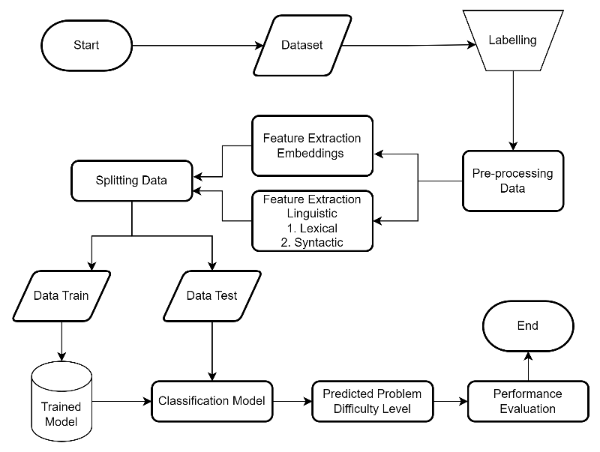
Figure 1. Question difficulty classification system
Based on Figure 1 shows the classification process of multiple-choice questions. Starting from collecting datasets as much as a total of 548 total question data which is then carried out the labeling process manually. Labeling is done by surveying teachers. After that, the data enters the pre-processing stage, where the data is processed so that it is more easily understood by the model. Then feature extraction is carried out to improve data quality and make the data more informative. After that, the data is split into train data and test data. Then the model classification process is carried out with several methods that have been mentioned. Then produce, predictions which are then evaluated for performance.
2.2 Data and Labeling
The data processed in this study are multiple choice questions of Indonesian Language and Mathematics from Elementary School and Junior High School levels. Multiple choice questions are obtained from question banks which are then collected according to the school level. The dataset consists of questions and difficulty labels. The construction of the dataset also involves manual labeling for the difficulty level categories of easy, medium, and difficult.
Table 1. Example of Indonesian question dataset
No | Question | Label
1. | Yang merupakan kalimat utama dari paragraf tersebut adalah ...  (The main sentence of the paragraph is...) | Difficult
2. | Pada kutipan cerita di atas, yang berupa kalimat aktif transitif adalah…  (In the story excerpt above, the transitive active sentence is....) | Medium
3. | Ciri bahasa dalam fabel biasanya bersifat ...  (Language characteristics in fables are usually...) | Easy
Table 2. Example of a Math question dataset
No | Question | Label
1. | Jumlah lima suku pertama suatu deret geometri adalah 93 dan rasio deret itu 2, hasil kali suku ke-3 dan ke-6 adalah ?  (The sum of the first five terms of a geometric sequence is 93, and the ratio of the sequence is 2. The product of the 3rd and 6th terms is?) | Difficult
2. | Pak Adi meminjam uang di Bank Indonesia sebesar Rp 15.000.000 dengan bunga 16% pertahun. Tentukan bunga yang ditanggung oleh Pak Adi jika akan meminjam selama tiga bulan…  (Mr. Adi borrows money from Bank Indonesia for Rp 15,000,000 with an interest rate of 16% per year. Determine the interest that Mr. Adi will bear if he borrows for three months…) | Easy
3. | Ibu Siti membeli empat gelondong kain untuk menjahit seragam paduan suara. Setelah selesai semua baju dijahit, ternyata kain masih sisa 3 meter. Bentuk aljabar kain yang digunakan adalah ...  (Siti bought four skeins of fabric to sew the choir uniforms. After all the clothes were sewn, 3 meters of fabric remained. The algebraic form of the fabric used is ....) | Medium
Based on tables 1 and 2 are examples of Indonesian and Mathematics questions, along with the labels that have been determined. The labeling process was done manually and analyzed by Indonesian and Mathematics teachers at each school level. Labeling was done using a dataset of 548 questions. Elementary multiple-choice questions consist of 185 Indonesian language questions and 121 mathematics questions. Meanwhile, junior high school multiple choice questions comprised 121 Indonesian and 120 Mathematics questions. The labeling of questions is divided into 3 level categories: easy, medium, and difficult. The category is then given a value of -1 for the easy category, 0 for the medium category, and 1 for the difficult category.
2.3 Data Pre-processing
Data pre-processing is one of the processes in system design that aims to help algorithms improve their performance while reducing computational complexity [8]. Data pre-processing also prepares the text to make it more effective and suitable for modeling needs. The following are the steps of data pre-processing.
- Data Cleansing to clean data from double spaces, punctuation, and URLs.
- Case Folding to simplify text into lowercase letters.
- Tokenization to separate text into smaller parts or called words.
- Normalization to simplify the text into a standard form.
Table 3. Example of data pre-processing
Pre-processing | Question | Result
Data Cleansing | Bacalah teks di bawah ini ! Saat naik bus, Rio mendapat tempat duduk. Di sebelahnya ada seorang ibu hamil yang berdiri. Sikap Rio sebaiknya  (Read the text below! When riding the bus, Rio got a seat. Next to him was a pregnant woman standing. Rio's attitude should be) | Bacalah teks di bawah ini Saat naik bus Rio mendapat tempat duduk Di sebelahnya ada seorang ibu hamil yang berdiri Sikap Rio sebaiknya  (Read the text below When riding the bus Rio got a seat Next to her was a pregnant woman standing Rios attitude should be)
Case Folding | Bacalah teks di bawah ini Saat naik bus Rio mendapat tempat duduk Di sebelahnya ada seorang ibu hamil yang berdiri Sikap Rio sebaiknya  (Read the text below When riding the bus Rio got a seat Next to her was a pregnant woman standing Rios attitude should be) | bacalah teks di bawah ini saat naik bus rio mendapat tempat duduk di sebelahnya ada seorang ibu hamil yang berdiri sikap rio sebaiknya  (read the text below when riding the bus rio gets a seat next to him there is a pregnant woman who stands rios attitude should be)
Tokenization | bacalah teks di bawah ini saat naik bus rio mendapat tempat duduk di sebelahnya ada seorang ibu hamil yang berdiri sikap rio sebaiknya  (read the text below when riding the bus rio gets a seat next to him there is a pregnant woman who stands rios attitude should be) | [bacalah, teks, di, bawah, ini, saat, naik, bus, rio, mendapat, tempat, duduk, di, sebelahnya, ada, seorang, ibu, hamil, yang, berdiri, sikap, rio, sebaiknya]  ([read, text, below, this, while, riding, the, bus, rio, gets, a, seat, next, to, there, is, a, mother, pregnant, who, stands, attitude, rio, should])
Normalization | [bacalah, teks, di, bawah, ini, saat, naik, bus, rio, mendapat, tempat, duduk, di, sebelahnya, ada, seorang, ibu, hamil, yang, berdiri, sikap, rio, sebaiknya]  (([read, text, below, this, while, riding, the, bus, rio, gets, a, seat, next, to, there, is, a, mother, pregnant, who, stands, attitude, rio, should])) | [bacalah, teks, di, bawah, ini, saat, naik, bus, rio, mendapat, tempat, duduk, di, sebelahnya, ada, seorang, ibu, hamil, yang, berdiri, sikap, rio, sebaiknya]  ([read, text, below, this, while, riding, the, bus, rio, gets, a, seat, next, to, there, is, a, mother, pregnant, who, stands, attitude, rio, should])
Table 3 shows the results of each pre-processing stage. Data cleansing produces text by removing punctuation marks. Case folding produces text with all lowercase letters. Tokenization produces text that is separated per word. Normalization produces standard text.
2.4 Features
The dataset in the form of questions processed in data pre-processing is then continued with the feature extraction process. Several features are modeled to predict scores, and in this final project, three features are used. First, the embedding feature is a feature in NLP, where each vocabulary has a vector that has meaning and is mapped as a real number vector [9]. The Embeddings feature used is Word2Vec. Word2Vec represents words into vectors, the dimension of the weight matrix is the number of words in the corpus multiplied by the number of hidden neurons [10]. Furthermore, linguistic features are language markers that have certain meanings and explain differences in how languages are written. The following is a complete explanation of each feature.
2.4.1 Embeddings
The embedding extraction feature used in this research is Word2Vec. Word2Vec is the name of the word vector representation created by Google. Word2vec was chosen because it uses the Dense Matrix feature and can reduce the dimensions to be denser than Term Frequency (TF) which uses Sparse Matrix, so it is expected to provide better results [9]. Word2vec represents numerical vectors based on words that often appear together in sentences. The word2vec model is then trained to represent word vectors based on the dictionary and context of co-occurring words. The model can then extract feature vectors from the words. The word2vec model uses a pre-trained model of the Indonesian Wikipedia corpus with a size of 100 vectors.
2.4.2 Linguistic
The linguistic features used in this research are as follows.
- Lexical Features
Lexical is the density of grammar. Lexical measurement based on text complexity measure the total number of words with lexical properties divided by the total number of orthographic words [11]. The lexical feature used in this research is TF-IDF (Term Frequency-Inverse Document Frequency). TF-IDF method is a technique used to calculate the relative frequency of each word in a text [12]. This method gives a value to each word based on the level of importance or the number of occurrences of the word in the document [12]. The TF-IDF equation can be seen in equation 1.

$TFidf=\frac{t}{d}×idf$ dengan $idf=log⁡(\frac{N}{df(t)})$ (1)
Based on equation 1, where t is the number of occurrences of a word in document d. While d is the total number of words in the document. In the idf equation, N is the total number of documents, and df(t) is the number of documents with the word t.
- Syntactic Features
Syntactic features refer to features extracted from a question based on the structure of the words in the question [13]. The syntactic features used in this research are grammatical words. The resulting grammatical categories are generally nouns (NN), adjectives (JJ), and verbs (VERB). The application of syntactic feature analysis in this study uses POS tagging. Syntactic feature applies POS tagging features or accurate word class labeling and provides grammatical information from each word in the sentence.
2.5 Text Classification
Questions that have undergone feature extraction are then continued with the text modeling or classification process. Classification is the process of classifying documents into one or more predefined categories or into classes of similar documents[2]. Classification in NLP can directly analyze text and form categories according to the given content. The following is the text classification used in this research.
2.5.1 Random Forest
The first method used is Random Forest. The implementation of the model uses a library with the Python programming language. The output of this model is a prediction of the difficulty level of questions based on a dataset that has gone through pre-processing of feature extraction data. Random Forest is a popular machine learning algorithm that inserts many decision trees into each sub of the data set and uses the average value to improve prediction [14]. The decision tree consists of root, internal, and leaf nodes [15]. The following are the completion stages of the Random Forest method [16]: (1) Assign a number of trees (k) from all m features where k is a smaller number than m; (2) Next, random sampling of N from the dataset for each tree is performed; (3) Then a random subset is taken. This subset consists of m predictors, where m is a number smaller than p, where p is the total number of predictor variables; (4) Next, the second and third steps will be repeated k times until the number of k trees is reached.
2.5.2 Support Vector Machine
The second method used is SVM. SVM is a classification algorithm that functions to classify non-linear data and liner data[17]. The concept of SVM is used to find the best hyperline, which is very important to limit two classes. The best hyperline can be obtained by measuring the margin of the hyperline and determining the best point.
2.5.3 Gaussian Process
The third method used is the Gaussian Process. Gaussian Process is a non-parametric process that can inherently generate probabilities [18]. The model used is Naïve Bayes which uses Bayes' Theorem. Naïve Bayes assumes the value of an attribute in a class is independent of other values. The naïve bayes formula used is found in equation 2.
$P\left(H | X\right)=\frac{P(X|H)P(H)}{P(X)}$ (2)
Based on equation 2, X is evidence, H is hypothesis, P(H|X) is the posterior probability of H conditional on X, P(X|H) is the posterior probability of X conditional on H, P(H) is the prior probability of hypothesis H, P(X) is the prior probability of evidence X.
2.5.4 Dense Neural Network
The fourth method used is the Dense Neural Network. NN is one of the most commonly used layers of neural networks and is connected to each neuron. Dense NN receives the output of the last neuron, which is processed by matrix-vector multiplication. The matrix vector formula used is found in equation 3.
$$A_{x}=\left[\begin{aligned}\begin{matrix}a_{11} & a_{12} ⋯ \end{matrix} a_{12} \\ \begin{matrix}a_{21} & a_{22} ⋯ \end{matrix} a_{2n} \\ \begin{matrix} ⋮ & ⋮ ⋱ \end{matrix} ⋮ \\ \begin{matrix}a_{m1} & a_{m2} ⋯ \end{matrix} a_{mn}\end{aligned}\right]\left[\begin{aligned}\begin{matrix}x_{1} \\ x_{2}\end{matrix} \\ ⋮ \\ x_{n}\end{aligned}\right] =\left[\begin{aligned}a_{11}x_{1}+ a_{12}x_{2}+ ⋯+ a_{1n}x_{n} \\ a_{21}x_{1}+ a_{22}x_{2}+ ⋯+ a_{2n}x_{n} \\ \begin{matrix}⋮ & ⋮ & ⋱\end{matrix} ⋮ \\ a_{m1}x_{1}+ a_{m2}x_{2}+ ⋯+ a_{mn}x_{n}\end{aligned}\right]$$ | (3)
Based on equation 3, the row vector has the same number of columns as the column vector. The previous layer's row vector (output) equals the column vector of the dense layer where A is an (M x N) matrix.
2.5.5 Logistic Regression
The fifth method used is Logistic Regression. Logistic regression applies probability to predict a classification [19]. Logistic regression aims to identify the relationship between independent variables and one or more dependent variables by using probability as a predictive value for the dependent variable. The formulas of logistic regression can be seen in equations 4.
$P\left(y=1|x\right)=\frac{1}{1+e^{-(β_{0}+β_{1}x)}}$ (4)
Based on equation 4, P is the probability based on the value of the independent variable. e is the Euler constant used to calculate the exponential function. $β_{n}$are the coefficients or weights determined during the model training process. x1, x2, ... are the values of the independent variables used to predict the probability of the target variable y.
2.6 Multiclass Confusion Matrix
After going through the modeling process, the last process is the evaluation process. This process will measure the performance and classification results with a matrix. Confusion Matrix is widely used in machine learning for supervised classification or determining classification models [20]. The confusion matrix analyzes how well the classification model recognizes different classes [16]. This research uses three categories to apply a multiclass confusion matrix with NxN dimensions to include all possible combinations of predicted and actual classes [21]. The resulting output is accuracy, recall, precision, and F1-Score based on the question dataset that has passed the classification process with the five methods.
$Accuracy=\frac{(TP1+TP2+…+TPn)}{(TP1 + TP2 + ... + TPn + FP1 + FP2 + ... + FPn + FN1 + FN2 + ... + FNn)}$ (5)
$Recall=\frac{(TP1+TP2+…+TPn)}{(TP1 + TP2 + ... + TPn + FN1 + FN2 + ... + FNn)}$ (6)
$Precision=\frac{(TP1 + TP2 + ... + TPn)}{(TP1 + TP2 + ... + TPn + FP1 + FP2 + ... + FPn)}$ (7)
$F1-Score=2×\frac{(Presisi×Recall)}{(Presisi+Recall)}$ (8)
Based on equation 5 accuracy counts all correct predictions divided by the number of questions, equation 6 is recall shows the number of actual positive questions that were predicted correctly, equation 7 is precision the number of questions or questions that are predicted correctly and equation 8 is f1-score the harmonic mean between recall and precision. With the information TP is True Positive, FP is False Positive, and FN is False Negative. TP indicates when the prediction results of the question match the actual conditions. FP and FN indicate when the prediction results do not match the actual conditions.
- RESULT AND DISCUSSION
This study predicts the difficulty level of questions using a dataset of multiple choice questions in Indonesian and mathematics at the elementary and junior high school levels labeled as easy, medium, and difficult. Three types of feature extraction are embedding, lexical, and syntactic features. Then the study continued by applying five classification methods: Random Forest, Support Vector Machine, Gaussian Process, Dense Neural Network, and Logistic Regression. The classification of question difficulty prediction was built with five scenarios. The first scenario determines the classification prediction results of each method using embeddings feature extraction. The second scenario determines the classification prediction results of each method using lexical feature extraction. The third scenario determines the classification prediction results of each method using syntactic feature extraction. The fourth scenario determines the classification prediction results of each method using lexical feature extraction and syntactic features. The fifth scenario determines the classification prediction results of each method using embeddings feature extraction and syntactic features. The last scenario determines the prediction results with the dense neural network model without involving feature extraction. Then the classification results of each scenario are compared and analyzed.

Data
In this study, the data used amounted to 548 questions consisting of 185 elementary Indonesian questions, 121 elementary mathematics questions, 121 junior high school Indonesian questions, and 120 junior high school mathematics questions. This data uses three class categories, consisting of easy, medium and difficult. The distribution of the label data obtained can be seen in Figures 3, 4, 5 and 6.
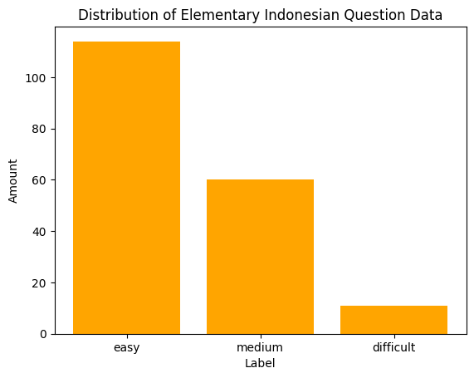 | 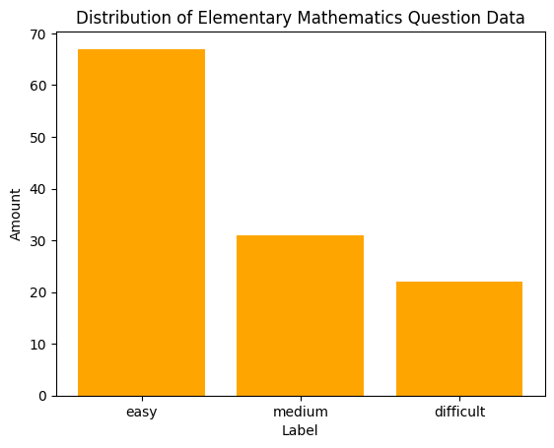
Figure 2. Distribution of primary school Indonesian questions | Figure 3: Distribution of elementary mathematics questions
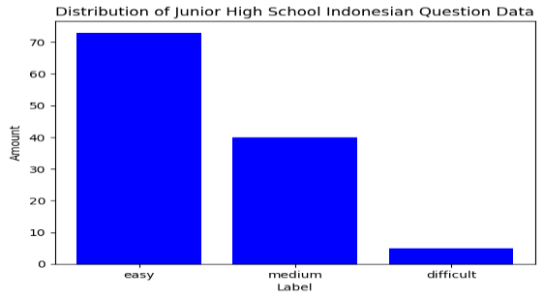 | 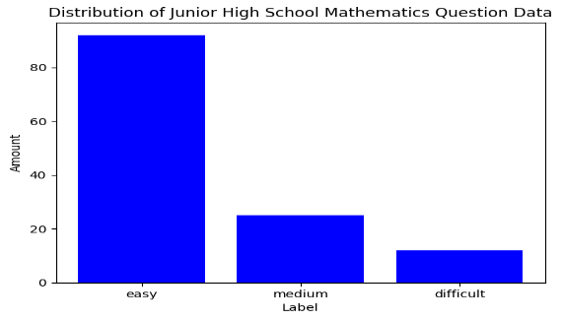
Figure 4: Distribution of junior high school Indonesian questions | Figure 5: Distribution of junior high school math questions
Based on Figure 2, the data distribution shows 114 easy questions, 60 medium questions and 11 difficult questions. Figure 3 shows 67 easy questions, 31 medium questions, and 22 difficult questions. Figure 4 shows 73 easy questions, 40 medium questions, and 5 difficult questions. Then Figure 5 shows 92 easy questions, 25 medium questions, and 12 difficult questions.Based on the distribution of data, the questions experience data imbalance. Labels with easy categories are more than labels in the medium and difficult categories. Labeling is done by surveying elementary and junior high school teachers who teach Indonesian and Mathematics subjects. The labels used in this study were converted to numeric, with -1 being the easy category, 0 being the medium category, and 1 being the difficult category.

Classification with Embedding Feature
The purpose of scenario 1 is to compare the best accuracy results of the classification model used. In the first scenario, the model's accuracy will be tested by applying embedding feature extraction to the dataset. The embeddings feature used is word2vec which represents words into vectors. The results of the first scenario can be seen in Table 4.
Table 4. Classification accuracy results with feature embedding
Model  Ratio (20 : 80) | Elementary school |  | Junior High School
Model  Ratio (20 : 80) | Indonesian | Math | Indonesian | Math
Random Forest | 0,70 | 0,79 | 0,75 | 0,70
SVM | 0,56 | 0,75 | 0,25 | 0,62
Naïve Bayes | 0,54 | 0,58 | 0,67 | 0,42
Logistic Regression | 0,70 | 0,75 | 0,25 | 0,58
Based on Table 4, the Random Forest classification model obtains the highest accuracy results. This experiment uses a splitting ratio 20:80 with 20 test data and 80 train data. Accuracy in Random Forest using embeddings feature extraction produces relatively high values in all elementary and junior high school question datasets trials. The highest accuracy for the first scenario is 79%. Meanwhile, the lowest accuracy was obtained by the SVM and Naïve Bayes models with an accuracy of 25%. This happens because SVM uses an optimal linear separator hyperline so that SVM is more complex in mapping linearly on a small dataset. Meanwhile, naïve bayes assumes the features in the dataset are independent of each other.

Classification with Lexical Feature
The purpose of the second scenario is to compare the best accuracy results of the classification model using lexical feature extraction. The lexical feature used is TF-IDF. TF-IDF feature extraction will give value to the words that often appear in the sentence. The results of the second scenario can be seen in Table 5.
Table 5. Classification accuracy results with feature lexical
Model  Ratio (20 : 80) | Elementary school |  | Junior High School
Model  Ratio (20 : 80) | Indonesian | Math | Indonesian | Math
Random Forest | 0,70 | 0,83 | 0,83 | 0,71
SVM | 0,59 | 0,79 | 0,79 | 0,71
Naïve Bayes | 0,56 | 0,66 | 0,38 | 0,45
Logistic Regression | 0,64 | 0,79 | 0,79 | 0,71
Based on Table 5, the Random Forest model obtains the highest accuracy results. This second scenario also uses a splitting ratio 20:80 with 20 test data and 80 train data. TF-IDF feature extraction produces relatively high accuracy in the Random Forest classification model. The highest accuracy in the second scenario is 83% on elementary school math and junior high school Bahasa Indonesia questions. This is because the Random Forest model uses a collective decision tree. The decision tree looks at a subset of words at each iteration, meaning that TF-IDF will be more informative in giving weight to different words.

Classification with Syntactic Feature
The purpose of the third scenario is to compare the best accuracy results of the classification model using syntactic feature extraction. The syntactic feature used is POS tagging. POS tagging will pay attention to the grammatical structure of each word in the sentence by tagging each word based on the word type. The results of the third scenario can be seen in Table 6.
Table 6. Classification accuracy results with feature syntactic
Model  Ratio (20 : 80) | Elementary school |  | Junior High School
Model  Ratio (20 : 80) | Indonesian | Math | Indonesian | Math
Random Forest | 0,56 | 0,79 | 0,58 | 0,75
SVM | 0,68 | 0,75 | 0,67 | 0,62
Naïve Bayes | 0,38 | 0,54 | 0,12 | 0,67
Logistic Regression | 0,64 | 0,67 | 0,50 | 0,04
Based on Table 6, the Random Forest model obtains the highest accuracy results. POS tagging feature extraction produces relatively high accuracy in the Random Forest and SVM classification models. The highest accuracy in the third scenario is 79% on elementary math questions. POS tag feature can provide information representation to Random Forest to take advantage of the word's context.

Classification with Lexical and Syntactic Feature
The purpose of the fourth scenario is to compare the best accuracy results of the classification model by combining two feature extractions. The feature extractions used are lexical features and syntactic features. The results of the fourth scenario can be seen in Table 7.
Table 7. Classification accuracy results with lexical and syntactic feature
Model  Ratio (20 : 80) | Elementary school |  | Junior High School
Model  Ratio (20 : 80) | Indonesian | Math | Indonesian | Math
Random Forest | 0,62 | 0,75 | 0,54 | 0,70
SVM | 0,68 | 0,79 | 0,79 | 0,70
Naïve Bayes | 0,27 | 0,67 | 0,33 | 0,12
Logistic Regression | 0,56 | 0,79 | 0,79 | 0,67
Based on Table 7, the highest accuracy is obtained by the SVM and Logistic Regression models. The two feature extractions combined produce the highest accuracy of 79% in SVM and Logistic Regression. The TF-IDF feature provides word weights based on the frequency of occurrence in documents, while POS tag delivers an understanding of the structure and context of words in sentences. So that when the two features are combined, it will produce a more complete representation of words about the text.

Classification with Embedding and Syntactic Feature
The purpose of the fifth scenario is to compare the best accuracy results of the classification model by combining two feature extractions. The feature extractions used are embeddings and syntactic features, where the methods used for these features are Word2vec and POS tagging; the fifth scenario results can be seen in Table 8.
Table 8. Classification accuracy results with embedding and syntactic feature
Model  Ratio (20 : 80) | Elementary school |  | Junior High School
Model  Ratio (20 : 80) | Indonesian | Math | Indonesian | Math
Random Forest | 0,65 | 0,79 | 0,79 | 0,75
SVM | 0,57 | 0,75 | 0,25 | 0,62
Naïve Bayes | 0,54 | 0,58 | 0,67 | 0,41
Logistic Regression | 0, 70 | 0,75 | 0,25 | 0,58
Based on Table 8, the Random Forest model obtains the highest accuracy. The two combined extractions produced the highest accuracy of 79% in the random forest algorithm. The embeddings feature represents the semantic relationship between words and meaning in the text. In comparison, the POS tag feature provides syntactic information that can represent the text's relationship between words and meaning.

Classification with DNN Model
The sixth scenario compares the best accuracy results of the Dense Neural Network (DNN) classification model. DNN uses each neuron to receive input from the previous layer and will provide output to all neurons in the next layer. The results of the fourth scenario can be seen in Table 9.
Tabel 9. Classification accuracy results with DNN model
Model  Ratio (20 : 80) | Elementary School |  |  | Junior High School
Model  Ratio (20 : 80) | Indonesian |  | Math | Indonesian |  | Math
DNN | 0,57 | 0,79 |  | 0,79 | 0,71
Based on Table 9, the highest accuracy is obtained on the Elementary Mathematics and Elementary Indonesian datasets at 79%. In this scenario, only modeling directly with Dense Neural Network. This scenario does not involve any feature extraction, as with other scenarios.
Table 10. Comparison of the accuracy level of each model
Feature Extraction | Indonesian |  |  |  | Math
Feature Extraction | RF | SVM | Naïve Bayes | Logreg | RF | SVM | Naïve Bayes | Logreg
Elementary School
Embedding | 0,70 | 0,56 | 0,54 | 0,70 | 0,79 | 0,75 | 0,58 | 0,75
TF-IDF | 0,70 | 0,59 | 0,56 | 0,64 | 0,83 | 0,79 | 0,66 | 0,79
Fitur Sintaktik | 0,56 | 0,68 | 0,38 | 0,64 | 0,79 | 0,75 | 0,54 | 0,67
TF-IDF + Fitur Sintaktik | 0,62 | 0,68 | 0,27 | 0,56 | 0,75 | 0,79 | 0,67 | 0,79
Embedding + Fitur Sintaktik | 0,65 | 0,57 | 0,54 | 0,70 | 0,79 | 0,75 | 0,58 | 0,75
Model : DNN | 0,57 |  |  |  | 0,79
Junior High School
Embedding | 0,75 | 0,25 | 0,67 | 0,25 | 0,70 | 0,62 | 0,42 | 0,58
TF-IDF | 0,83 | 0,79 | 0,38 | 0,79 | 0,71 | 0,71 | 0,45 | 0,71
Fitur Sintaktik | 0,58 | 0,67 | 0,12 | 0,50 | 0,75 | 0,62 | 0,67 | 0,04
TF-IDF + Fitur Sintaktik | 0,54 | 0,79 | 0,33 | 0,79 | 0,70 | 0,70 | 0,12 | 0,67
Embedding + Fitur Sintaktik | 0,79 | 0,25 | 0,67 | 0,25 | 0,75 | 0,62 | 0,41 | 0,58
Model : DNN | 0,79 |  |  |  | 0,71
Based on Table 10, we can see a comparison of the accuracy of each model with different scenarios and from different datasets. Starting from the dataset of elementary Indonesian questions, we get the largest accuracy result at 70% using the Random Forest and Logistic Regression models. These accuracy results apply embedding and tf-idf extraction features before modeling. Then the elementary school mathematics question dataset gets the highest accuracy of 83% using tf-idf feature extraction, which is modeled with Random Forest. Furthermore, the junior high school Indonesian question dataset gets the highest accuracy of 83% from Random Forest using tf-idf feature extraction. The last dataset is junior high school math questions with the highest accuracy of 75% from Random Forest using syntactic feature extraction and a combination of Embedding + Syntactic Features. If we analyze the overall accuracy, Random Forest is the best model with high accuracy in predicting question difficulty. In addition, the best feature extraction is Embedding and TF-IDF. Of course, all the accuracy that has been obtained in each model is through pre-processing data, which is very influential in optimizing accuracy results. The data used in the research also has an effect, especially on label balance. If we look at the dataset used, there is an imbalance between the three labels, with more labels on easy questions. This can affect the train data trained on the classification model which also affects the prediction results. The experimental result shows that the best classification method on identifying question difficulty level is Random Forest, similar to the finding of a prior study by Le An Ha[3]. In the best feature extraction, Le An Ha produces embedding as the best feature extraction, and in this study, embedding and TF-IDF become the best feature extraction.
- CONCLUSION
In this study, we performed classification to predict the difficulty level of multiple choice questions in Indonesian language and mathematics at the elementary and junior high school levels using five methods and three feature extractions. The five methods used are Random Forest, SVM, Naïve Bayes, Logistic Regression, and DNN. The three feature extractions used are embedding, lexical and syntactic. Scenarios one, two, three, and five produced the highest accuracy in the Random Forest method and scenario four in the SVM and Logistic Regression methods. When viewed in the comparison table, the Random Forest method is also the best, with the highest accuracy in each type of question. Then for the best feature extraction, namely embedding, and TF-IDF. Based on the results of testing and comparison, it can be concluded that the Random Forest method gets the best accuracy in all four scenarios, and feature extraction affects the prediction results. The limitation of this research is the total number of questions that can still be increased so that the labeling can be generated evenly between each label so there is no data imbalance. This research also only uses question datasets from two subjects. Recommendations for further research are to conduct experiments with balanced data and can add more varied subjects. Each label has a balanced amount so the model can better classify text. Furthermore, you can do research with other feature extraction.
REFERENCES
1] T. Kesulitan et al., “Difficulty Level of Test Made by Teachers in the Field of Mathematics Subject according to Classical Test Theory at the Junior High School Level in Baubau City,” Jurnal Akademik Pendidikan Matematika, vol. 8, no. 1, pp. 33–40, May 2022, doi: 10.55340/JAPM.V8I1.699.
[2] L. Mutawalli, M. Taufan, A. Zaen, and W. Bagye, “KLASIFIKASI TEKS SOSIAL MEDIA TWITTER MENGGUNAKAN SUPPORT VECTOR MACHINE (Studi Kasus Penusukan Wiranto),” Jurnal Informatika dan Rekayasa Elektronik, vol. 2, no. 2, pp. 43–51, Dec. 2019.
[3] L. A. Ha, V. Yaneva, P. Baldwin, and J. Mee, “Predicting the Difficulty of Multiple Choice Questions in a High-stakes Medical Exam,” ACL 2019 - Innovative Use of NLP for Building Educational Applications, BEA 2019 - Proceedings of the 14th Workshop, pp. 11–20, 2019, doi: 10.18653/V1/W19-4402.
[4] M. A. Byrd and S. Srivastava, “Predicting Difficulty and Discrimination of Natural Language Questions,” Proceedings of the Annual Meeting of the Association for Computational Linguistics, vol. 2, pp. 119–130, 2022, doi: 10.18653/V1/2022.ACL-SHORT.15.
[5] A. pramono, “Analisis Butir Soal Pilihan Ganda Menggunakan Fuzzy Berdasar Data Learning Management System Studi Kasus: SMK Negeri 2 Kediri,” Cahaya Tech, vol. 7, no. 01, 2018, doi: 10.47047/ct.v7i1.3.
[6] T. Rishith Reddy, M. Boddu, B. Bhagya Rishiroop, R. Rajkumar, and Ds. Reddy, “Difficulty Level Prediction of a Question Paper Using Naive Bayes Classifier Big Data for Satellite Image Processing:Analytics, Tools, Modeling, and Challenges View project Healthcare Data Analytics View project Difficulty Level Prediction of a Question Paper Using Naive Bayes Classifier,” Journal of Xi’an University of Architecture & Technology, Sep. 2020, doi: 10.37896/JXAT12.09/2928.
[7] M. Sari, M. Y. Kurniawan, and W. Wagino, “KLASTERING TINGKAT KESULITAN SOAL PEMROGRAMAN BERORIENTASI OBJEK MENGGUNAKAN K-MEANS,” Prosiding Penelitian Dosen UNISKA MAB, vol. 0, no. 0, Nov. 2020, doi: 10.31602/PPDU.V0I0.3781.
[8] V. Th Stergiopoulos, T. V Tsianaka, and E. N. Tousidou, “AMiner Citation-Data Preprocessing for Recommender Systems on Scien-tific Publications,” 2021, doi: 10.1145/3503823.3503828.
[9] F. Rahutomo et al., “EVALUASI FITUR WORD2VEC PADA SISTEM UJIAN ESAI ONLINE,” JIPI (Jurnal Ilmiah Penelitian dan Pembelajaran Informatika), vol. 4, no. 1, pp. 36–45, Jun. 2019, doi: 10.29100/JIPI.V4I1.1098.
[10] A. Nurdin, B. Anggo, S. Aji, A. Bustamin, and Z. Abidin, “PERBANDINGAN KINERJA WORD EMBEDDING WORD2VEC, GLOVE, DAN FASTTEXT PADA KLASIFIKASI TEKS,” Jurnal Tekno Kompak, vol. 14, no. 2, pp. 74–79, Aug. 2020, doi: 10.33365/JTK.V14I2.732.
[11] Y. Purnamasari, “Keterbacaan Teks Kesehatan dalam Website WHO pada Masa Pandemi Covid-19,” Alinea: Jurnal Bahasa, Sastra, dan Pengajaran, vol. 10, no. 2, pp. 94–105, Oct. 2021, doi: 10.35194/alinea.v10i2.1479.
[12] F. Rozi, F. Rozi, F. Sukmana, and M. N. Adani, “Pengelompokkan Judul Buku dengan Menggunakan Algoritma K-Nearest Neighbor (K-NN) dan Term Frequency – Inverse Document Frequency (TF-IDF),” JIMP (Jurnal Informatika Merdeka Pasuruan), vol. 6, no. 3, Dec. 2021, doi: 10.37438/jimp.v6i3.346.
[13] Z. Rakhmawati, S. Basuki, and G. W. Wicaksono, “Klasifikasi Kalimat Tanya Berdasarkan Taksonomi Bloom Menggunakan Support Vector Machine,” Jurnal Repositor, vol. 2, no. 4, pp. 427–436, Mar. 2020, doi: 10.22219/REPOSITOR.V2I4.69.
[14] Y. Lei, “Application of Random Forest Prediction Technology in the Management of Public Opinion Events in Colleges and Universities,” ACM International Conference Proceeding Series, pp. 2966–2969, Oct. 2021, doi: 10.1145/3495018.3501216.
[15] V. Wanika Siburian, J. Sistem Komputer Universitas Sriwijaya Palembang, and I. Elvina Mulyana, “Prediksi Harga Ponsel Menggunakan Metode Random Forest,” Prosiding Annual Research Seminar, 2018.
[16] U. Erdiansyah, A. I. Lubis, and K. Erwansyah, “Komparasi Metode K-Nearest Neighbor dan Random Forest Dalam Prediksi Akurasi Klasifikasi Pengobatan Penyakit Kutil,” JURNAL MEDIA INFORMATIKA BUDIDARMA, vol. 6, no. 1, pp. 208–214, Jan. 2022, doi: 10.30865/MIB.V6I1.3373.
[17] H. Nalatissifa et al., “Perbandingan Kinerja Algoritma Klasifikasi Naive Bayes, Support Vector Machine (SVM), dan Random Forest untuk Prediksi Ketidakhadiran di Tempat Kerja,” vol. 5, no. 4, pp. 2622–4615, 2020, doi: 10.32493/informatika.v5i4.7575.
[18] Y. Ding and M. Mcculloch, “Additive Gaussian process prediction for electrical loads compared with deep learning models,” 2021, doi: 10.1145/3447555.3466592.
[19] F. Handayani et al., “Komparasi Support Vector Machine, Logistic Regression Dan Artificial Neural Network Dalam Prediksi Penyakit Jantung,” JEPIN (Jurnal Edukasi dan Penelitian Informatika), vol. 7, no. 3, pp. 329–334, Dec. 2021, doi: 10.26418/JP.V7I3.48053.
[20] M. Hasnain, M. F. Pasha, I. Ghani, M. Imran, M. Y. Alzahrani, and R. Budiarto, “Evaluating Trust Prediction and Confusion Matrix Measures for Web Services Ranking,” IEEE Access, vol. 8, pp. 90847–90861, 2020, doi: 10.1109/ACCESS.2020.2994222.
[21] I. Markoulidakis, G. Kopsiaftis, I. Rallis, and I. Georgoulas, “Multi-Class Confusion Matrix Reduction method and its application on Net Promoter Score classification problem,” ACM International Conference Proceeding Series, pp. 412–419, Jun. 2021, doi: 10.1145/3453892.3461323.

